LAB REPORT
Lab Assignment 8: Page Replacement Algorithms

1. Objective
- To implement page replacement algorithms in C.
- To calculate the number of page faults using:
a) FIFO (First-In, First-Out) algorithm
b) Optimal Page Replacement algorithm
- To compare the efficiency of different replacement strategies in terms of page faults.

2. Theory
In virtual memory systems, processes may need more pages than the available physical frames. When this happens, a page replacement algorithm decides which page to remove from memory. The efficiency of such an algorithm is measured by the number of page faults it generates.
- Page Fault: Occurs when the required page is not in memory and must be loaded from disk.
a) FIFO (First-In, First-Out)
- The oldest page in memory is replaced first.
- Simple to implement using a queue.
- May suffer from Belady’s Anomaly (more frames don’t always mean fewer faults).
b) Optimal Page Replacement
- Replaces the page that will not be used for the longest time in the future.
- Produces the minimum possible page faults.
- Requires future knowledge of page references (used mainly for analysis).

3. Tools and Commands Used
- gcc – GNU C Compiler.
- Linux Terminal – For program execution.
- C Programming Language – Implementation of algorithms.

4. Procedure
- Input the number of frames and the reference string (page requests).
- Implement FIFO Algorithm:
  - Use a queue to maintain the order of pages.
  - On a page fault, replace the page at the front of the queue.
- Implement Optimal Algorithm:
  - For each page fault, check the future use of all pages in memory.
  - Replace the page that will not be used for the longest period.
- Calculate the total number of page faults for each method.
- Display results for comparison.

5. Program.
A> WAP to calculate page faults using FIFO
- Configure the Directory.
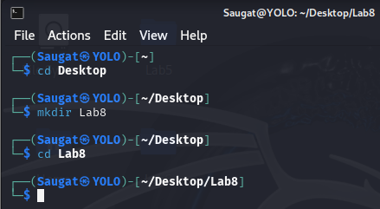
- Create the C-Language file.


- Write the respective FIFO code in C.
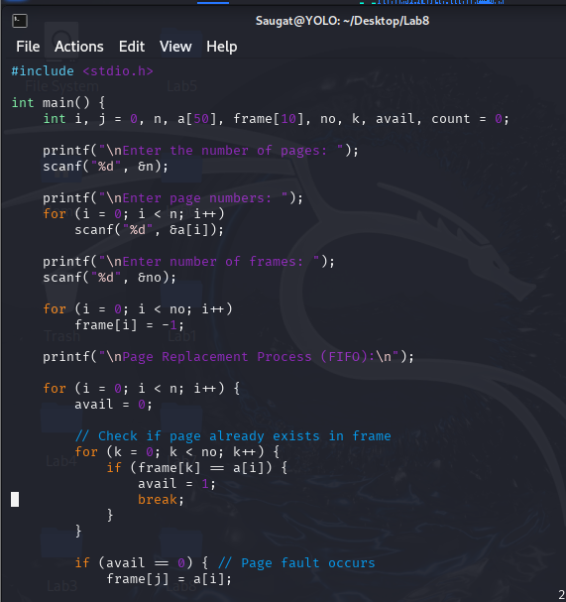
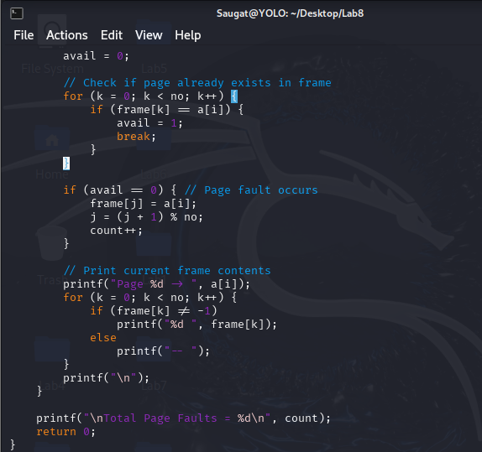
- Compile the File.
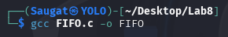

- Execute the file.
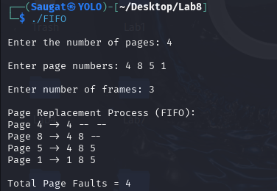
B> WAP to calculate page faults using Optimal Page Replacement.
- Create the C-Language file.
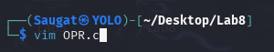
- Write the respective OPR code in C.
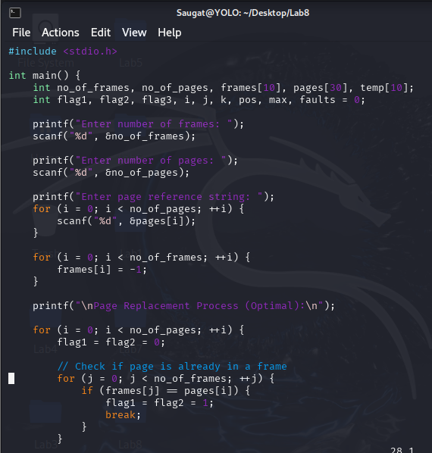
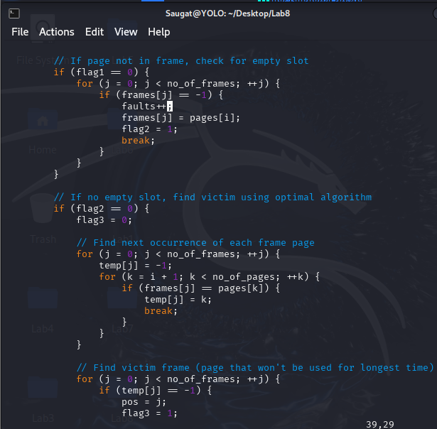
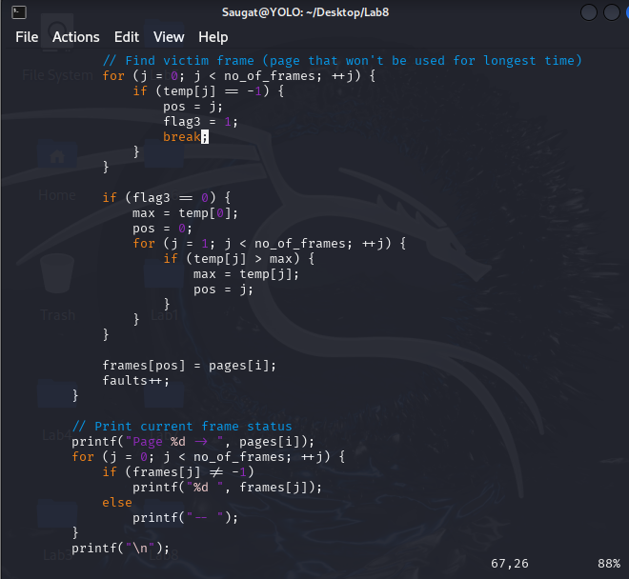
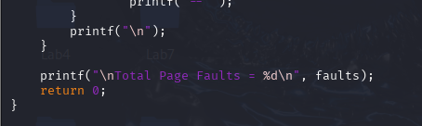
- Compile the File.

- Execute the file.
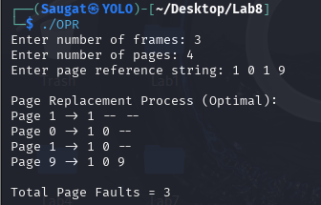

6. Conclusion
This lab demonstrated the working of two fundamental page replacement algorithms. FIFO provided a simple replacement policy but may lead to unnecessary page faults (Belady’s Anomaly). The Optimal algorithm minimized page faults by looking ahead in the reference string, but it is impractical in real systems as future requests are unknown. These simulations highlight the trade-offs in memory management strategies in operating systems.

